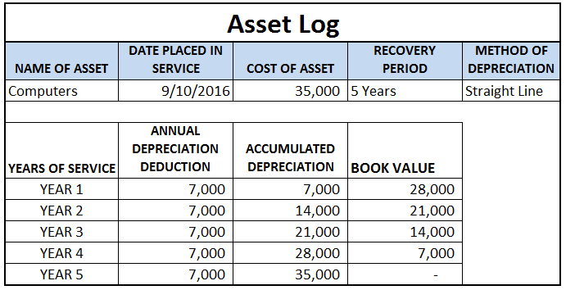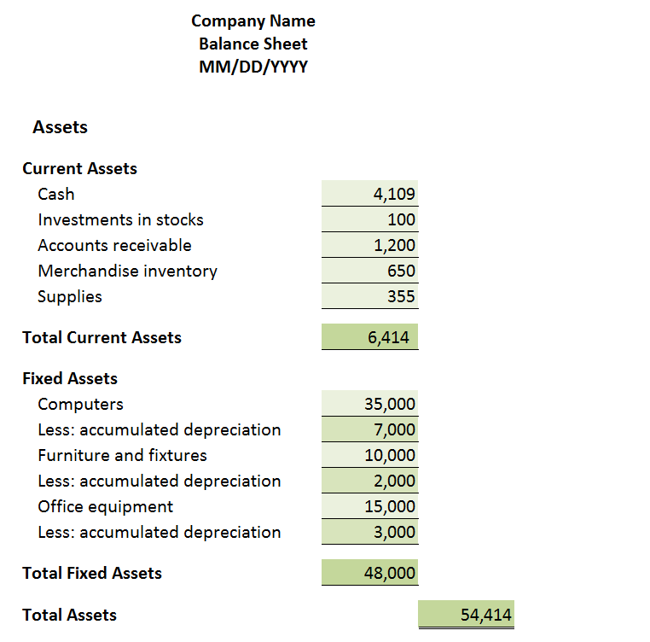

A

B

B

A

**From Journals to Statements (Balance Sheet- Assets)**

1. Asset cash should be consistent with ending cash balance on the Cash Budget at the end of the period. If the Balance Sheet is prepared for a specific day during the fiscal year, cash should be reflective of the firm’s bank account balance as of that day.
2. Accounts Receivable should match the sum of all unpaid accounts in the Sales Journal. If your firm has been in operation for more than one year, previous years’ receivables should be included as well. For accounts that are no longer collectable or have been proven difficult to collect, consider recording them as bad debt expenses. See resources on bad debt on the portal for details.
3. Merchandise Inventory should be consistent with firm’s Inventory Records.
4. Supplies should match what has been purchased in the Purchases Journal subtracting the amount that has already been used.
5. Purchased assets should be recorded in the Asset Log and show annual depreciation deduction for five years calculated using the 5 year straight line depreciation method. The Asset Log shown below shows computers purchased at the price of 35,000, annual depreciation deduction 7,000 which is 20% of the original price of 35,000.