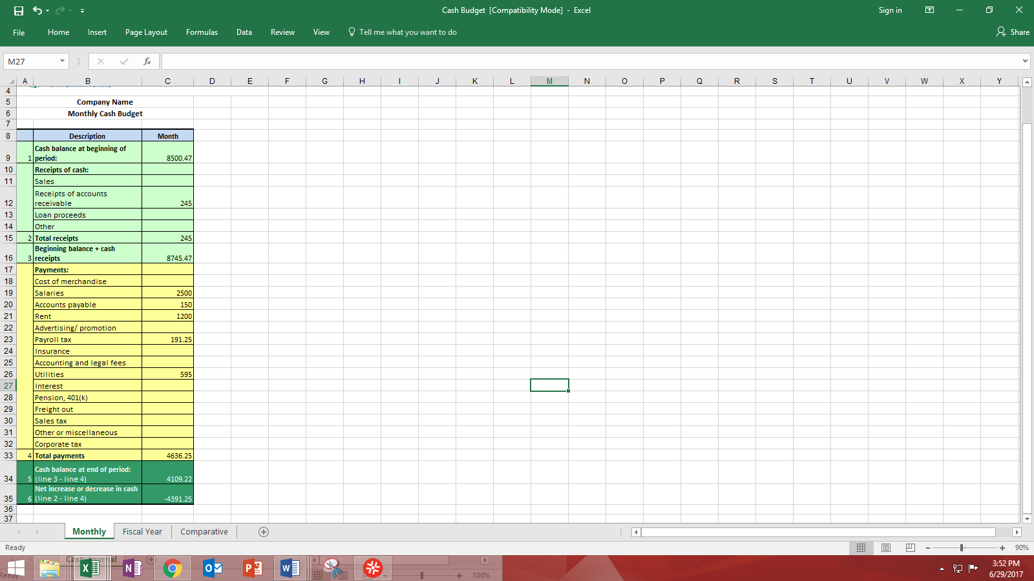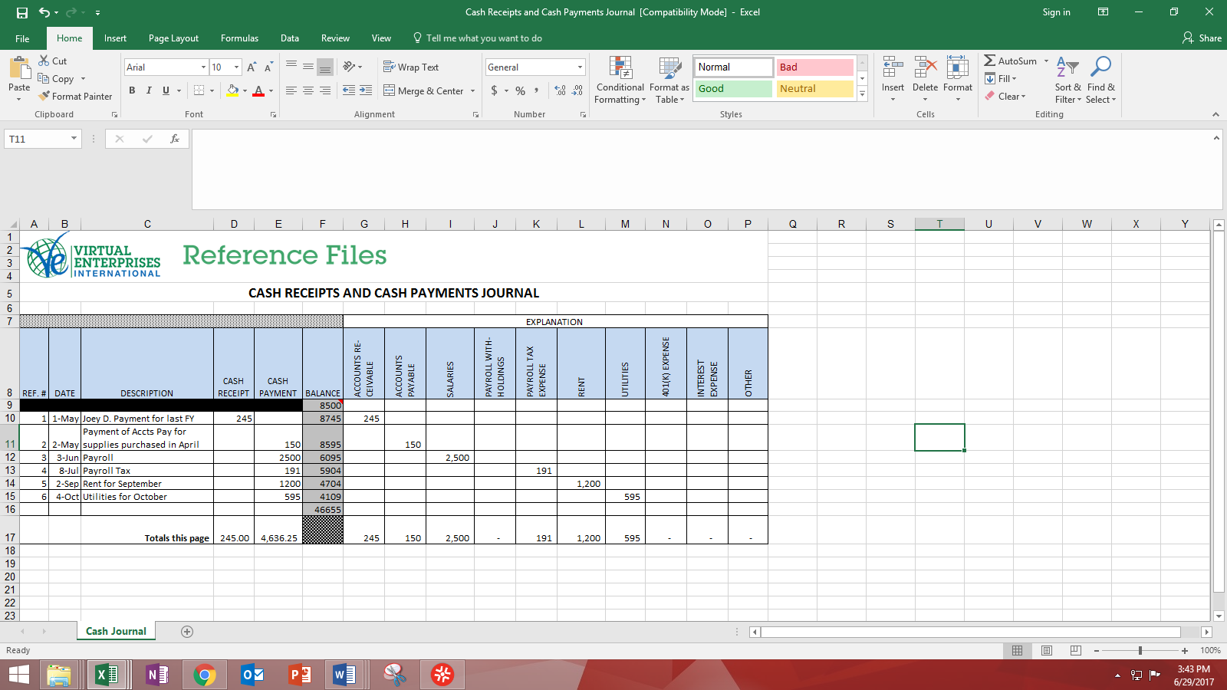

1

2

3

3

4

5

**From Journals to Statements (Cash Budget)**

1. Beginning balance from journal should match cash balance at beginning of period on Cash Budget
2. Filling out explanations on the right side of the journal while recording transactions helps with separating receipts and payments into their respective category rows on the actual statement
3. Totals for cash receipt and cash payment should be consistent with total receipts and total payments on Cash Budget
4. Cash balance at end of the period on the statement should equal to ending balance on the journal
5. At the end of the period, the difference in total cash receipt and cash payment should be consistent with net increase or decrease in cash on Cash Budget