Marketing/Sales Materials

How to find complete list of VEI Sales and Marketing Resources
- Sign into VE Portal
- Click ‘Sales and Marketing’ tab on the left side of the screen
- Explore the ‘Tasks,’ ‘Reference Files’ and ‘Video’ tabs
  - Ideation (Distinguish between the business idea that’s right for you and would work best rather than what doesn't?)
List of industries that firms have chosen for their businesses:
https://www.score.org/resource/choosing-business-idea-%E2%80%99s-right-you-4-important-questions-ask
https://portal.veinternational.org/fd/business-categories/
  - Discussing and setting up sales price, wholesale, inventory, shipping, tax, and profit margin
Sales Price - refer to pricing (one of the 5 P’s): http://resources.veinternational.org/sm/SALTASK4.pdf
Wholesale Marketplace User Manual: https://portal.veinternational.org/static/res/Marketplace%20Manual.pdf

Maintaining inventory records and inventory report:
C:\Users\admin\Desktop\Inventory Record Template.xlsx
http://resources.veinternational.org/sm/SALTASK15.pdf

  - Creating a website, and what is needed for a successful website
Common website hosts:
- https://www.wix.com/
- https://www.weebly.com/
- https://wordpress.com/

To see examples of websites, check out the US firm directory under the Explore tab on the VEI website, and click through the names of firms: https://veinternational.org/us-firm-directory/
These firms won the 2016-2017 VEI Website Competition (click the ‘16-17 Website’ tab on the left side): https://veinternational.org/competition-results/#16-17-online
  - Incorporating the buy button on your website and why it’s extremely recommended
Buy buttons and how to create them: https://portal.veinternational.org/storemanager/a937c46943474caab6d6135d5984df6e/documentation/

  - How to effectively promote your company in the VE Network
There are advertising firms within the VE network available to provide advertising services. Check out this list of firms in the US from the Portal: https://portal.veinternational.org/fd/business-categories/1/?cntry=US
The VEI website also offers slots to post an ad for your company.
FREE Websites to create posters, flyers, social media banners and other materials:
- https://www.canva.com/
- https://www.lucidpress.com/
  - Developing a marketing plan and an advertising campaign
Identifying your target market or customer profile: http://resources.veinternational.org/sm/SALTASK5.pdf

e.g. Avant-Garde Furnishings
- 14-18 year olds, earning 25K-70K, and high school graduate with some college education, living in an urban area in the U.S (taken from their 2016-2017 annual report)
Identifying the 5 P’s, or the Marketing Mix: http://resources.veinternational.org/sm/SALTASK4.pdf
Creating a Marketing Plan: http://resources.veinternational.org/sm/SALTASK7.pdf
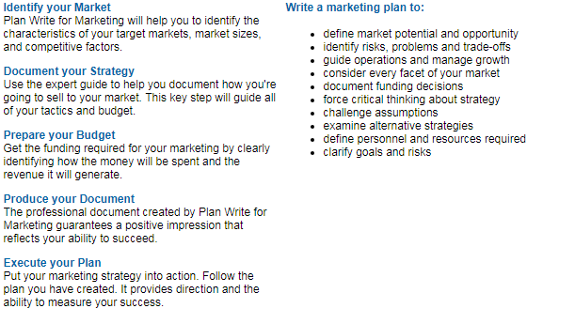
FREE Websites for market research (i.e. for creating and conducting surveys):
- https://www.surveymonkey.com/
- https://www.google.com/forms/about/
- https://www.jotform.com/ (limited number of forms)
- https://mailchimp.com/

See the do’s and don’ts of marketing: http://www.nycve.org/marketing.html
See the do’s and don’ts of sales: http://www.nycve.org/sales.html
  - Corporate Social Responsibility - How are your students giving back?
Some VE firms affiliate themselves with real companies, for example, MEOW & Friends is affiliated with North Shore Animal League America, an animal shelter. MEOW acts as an adoption agency for them. They also provide free advertising for animal shelters.
  - Methods of developing out of network sales
- Adapting Sales Resources for Foreign Markets: http://resources.veinternational.org/sm/SALTASK17.pdf
- Non-network business contracts: http://resources.veinternational.org/acc/out-of-network-business-contract-infomation.pdf
- http://www.nycve.org/uploads/8/9/4/6/89469972/out-of-network-business-contract-worksheet.xlsx
- Advertising strategies based on events throughout the fiscal year
Create special flyers, introduce seasonal products only available for a limited amount of time, or discounted items at certain times of the year, such as during Trade Shows, Christmas or Halloween.
- Trade Show Best Practices - sales pitches, funding, materials to prepare
A good way to practice pitching a sale: http://resources.veinternational.org/sm/SALTASK10.pdf
Helping students understand how to sell: http://resources.veinternational.org/sm/SALTASK9.pdf
Preparing for the Trade Show video: http://veinternational.org/webinars-tutorials/preparing-trade-show/
- Compare sales forecast with actual - best strategy if it’s not what was expected
Sales Forecast Template: http://resources.veinternational.org/sm/Sales%20Forecast%20Template.xlsx

- Public Relations - Promotion video/posters for course registration
FREE Websites to create posters, flyers, social media banners and other materials:
- https://www.canva.com/
- https://www.lucidpress.com/

